**Exploratory Data Analysis**

**Temperature Distribution**

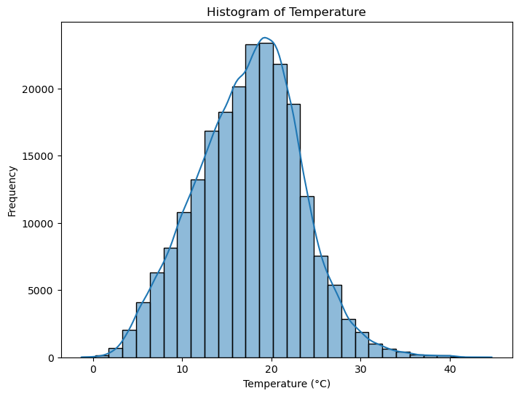

The Histogram above illustrates the temperature distribution in NSW as well as its density curve. The distribution appears to be roughly normal, centered around 20°C, with most temperatures ranging between 10°C and 30°C. There is a slight right skewness which indicates the presence of some higher temperature values that could be considered outliers. The density curve peaks near the average temperature.

**Demand Distribution**

The Demand Histogram depicts the distribution of electricity demand in megawatts (MW). The distribution appears normal with concentrated values around 8000 MW and most values are between 6000 MW and 10000 MW. The distribution shows a slight right skew, suggesting that there are some higher demand values, though they are less frequent. The density curve peaks at around the most frequent demand levels near 8000 MW

**Seasonality and Trend**

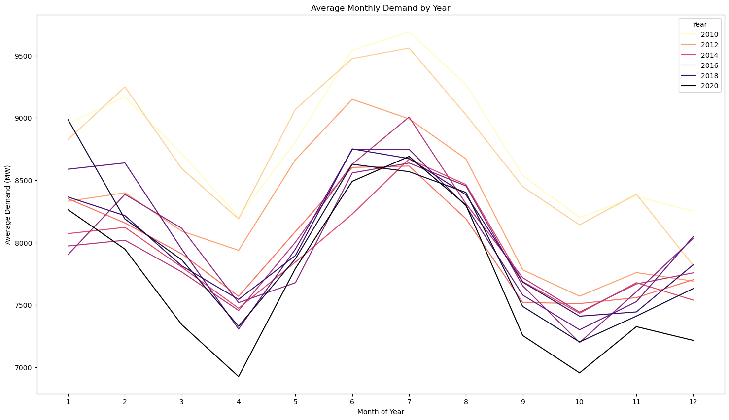

The electricity demand seems to follow a cyclical pattern each year with higher demand during the summer months (around December, January and February) and winter months (June, July and August), likely due to heating and cooling needs during those months, while spring and autumn see lower demand. Therefore, it is likely that temperature can greatly influence the demand of electricity.

Temperature peaks at around the same temperature and around the same time of the day, the pattern is consistent throughout the years.

**Relationship between Energy Demand and Temperature**

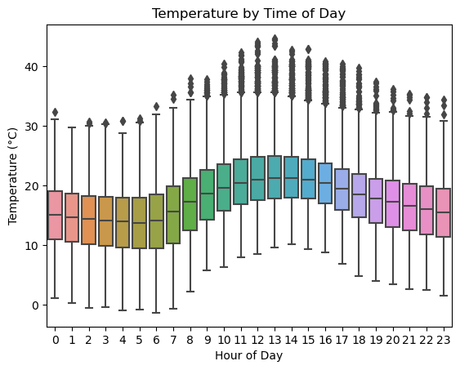

Further exploring the correlation between Temperature and Demand, by looking at the boxplots of Temperature during each hour of the day and the Demand during each hour of the day, we can see a very similar pattern where demand for electricity increases as temperature increases. This further suggests that temperature and demand likely have some correlation.

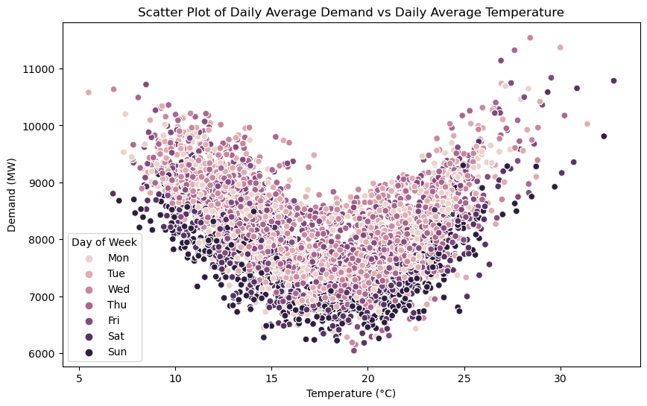

However, when we look at the Demand and Temperature Scatterplot, in which we have separated the day of the week by colour, we can see that the relationship exhibits a U-shape with demand being higher at both low (5-10°C) and high temperatures (above 25°C), while it drops at moderate temperatures (15-20°C). This suggests that there is a non-linear relationship between Demand and Temperature, as both heating and cooling requirements drive higher electricity consumption.

It is also evident that day of the week seem to have an influence on the demand level. Weekdays (Monday to Friday, lighter-coloured dots) generally have higher demand compared to weekends (darker-coloured dots). This pattern is consistent across the temperature range.

**Population**

Despite the population growth, electricity demand has not followed the same upward trajectory. The divergence between population and demand trends indicates that external factors (beyond just population growth) are influencing electricity consumption, making it a point of interest for further analysis.

Correlation between Demand and other potential features for modelling

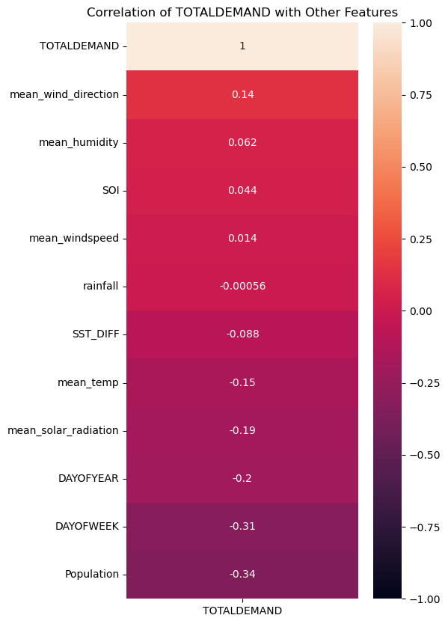

* Population (-0.34): Surprisingly, as population increases, electricity demand decreases, possibly due to improvements in energy efficiency and renewable energy adoption.
* Day of the Week (-0.31): Demand tends to be lower on weekends, reflecting reduced industrial and commercial activity.
* Day of the Year (-0.2): Electricity demand shows a weak seasonal decline over the course of the year.
* Weather-related factors (e.g., temperature, humidity, solar radiation): These have weak correlations with electricity demand, indicating that weather influences are present but not dominant drivers of demand.
* SOI (0.044): ENSO cycles (SOI) show minimal direct impact on demand.

Overall, these correlations suggest that factors like temporal patterns (weekday vs. weekend) and population changes might have more influence on electricity demand than weather conditions alone, warranting further analysis.

**Relationship between electricity demand and ENSO**

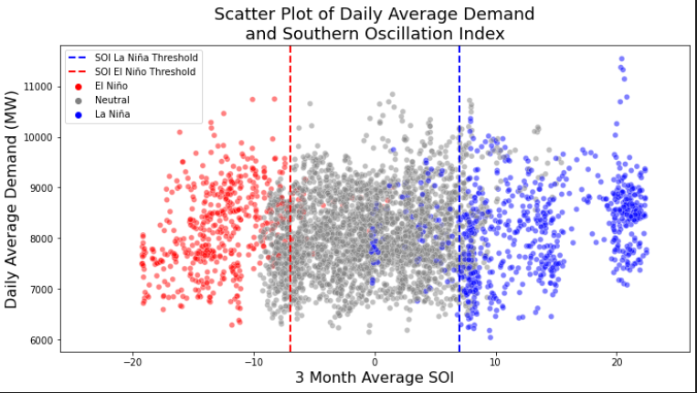

This scatterplot helps identify how different phases of the ENSO cycle impact electricity demand. The El Niño phase appears to have greater variability in demand, while La Niña conditions lead to more stable demand typically between 7,000 MW and 9,000 MW. The neutral phase exhibits a moderate spread of demand. Understanding this relationship can aid in forecasting electricity usage based on ENSO conditions. Do note that there are some potential outliers in the La Nina phase, this suggests that during La Nina, although demand is generally stable, there are occasional spikes or drops in demand.

Comparing the Yearly Demand Boxplot and the SOI Over Time Line plot, there seems to be slightly fewer fluctuations in demand in general during El Nino period (2015, 2016) compared to La Nina and Neutral periods. La Nina generally exhibits higher and more variable demand, however, 2012 does have the lowest fluctuations in demand in all the years we observed, therefore further investigation into additional factors would be necessary to draw firm conclusions.